Spring True Beginner Class –
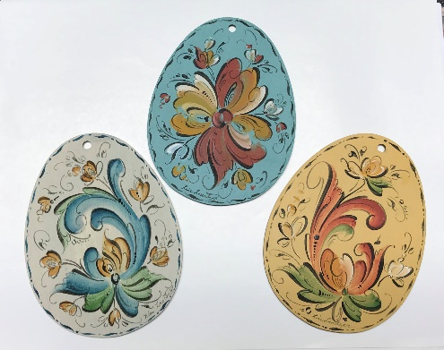
The Illinois Norsk Rosemalers Association is excited to have Lise Lorentzen (Facebook - Artoflise, YouTube - Rosemaling by Art of Lise) teach a virtual true beginner class March 23 & 25, 2021. This class will be taught online through the Zoom platform. Class instruction will include demonstrations and discussion, prerecorded video presentations and individual feedback. The class will be taught using acrylics and be limited to 14 students. Lise will be teaching in acrylics but students may use acrylics or oils as they prefer.
Focusing on the true beginner’s need for learning basic rosemaling stroke work, the class will include instruction for all the steps to completing a beginner rosemaling project. This spring class project will be three flat egg-shaped ornaments using original Telemark designs created for the class. Pattern packets ($20) with pictures, line drawings, step by step instructions, and three base-coated egg-shaped wooden ornaments are available separately from Lise as are acrylic paint kits ($5). An oil paint palette will be provided but oil paints must be purchased separately by a student if desired.
INRA members will have one week of advanced registration time for this class. Information about the class will be available on the INRA website and Facebook page as well as rosemalingclasses.com for the public starting February 15. Registration for this class will end on March 16 or when the class is full. If you have questions about registration, the class format or class details, contact Mari Smith at inrarosemaling@gmail.com.

To recap:
March 23 & 25 – Spring True Beginner class #1
Teacher’s Name: Lise Lorentzen
Project description: egg-shaped flat ornaments
Style: Transparent Telemark
Medium: Lise will be teaching in acrylics, oil painters are welcome
Level: True beginner
Class venue: Zoom (minimum 6 students, maximum 14)
Dates/Class Schedule: Tuesday, 3/23 and Thursday, 3/25, 7-10pm EST (6-9 PM Central)
Class Fee: $25/mem, $40/nonmember – covers $15 for 2021 membership to INRA
No refunds unless there is a student from a waitlist to take the vacated place.
Additional Estimated Costs: To be ordered as needed from Lise - pattern packet with three base-coated egg-shaped ornaments $20, and acrylic paints, $5. An oil paint palette will be provided but paints must be purchased separately by a student if desired. Ordering information will be included with supply list to be sent by email with confirmation of registration.

Artist’s bio - Lise Lorentzen has been rosemaling since the age of 12 and her art covers over 30 years of experience, specializing in custom painting of woodenware, furniture, and home interiors. Lise has been fortunate to study under many renowned Norwegian and American artists. Before moving to Maryland, Lise completed the New York State Council of the Arts (NYSCA) folk arts apprenticeship program studying with master artist Eldrid Arntzen, a National Endowment of the Arts recipient. She has also studied and taught Rosemaling at the Fletcher Farm School for the Arts and Crafts in Ludlow, Vt. for 20+ years.
Lise is a member of and teacher through Vesterheim, a Norwegian-American Museum in Decorah, IA, and competes in the museum’s annual folk-art competition. She has earned half of her points on her way to her Gold Medal with third place in 2013 and 2014 and a second place in 2015. She also has several honorable mentions, most recently in 2016. She has also taught and had her work on display at the Staten Island Museum as well as the Norwegian Seaman’s Church in NYC. In 2014, Lise received First place at the Sons of Norway Third District. In November of 2017 Lise started recording rosemaling videos for her Facebook page, https://www.facebook.com/ArtofLise1/. She started a YouTube channel, Rosemaling by Art of Lise in July of 2019 and taught her first online class in July of 2020. We are delighted to have her back again to teach three classes for the INRA in 2021.

EDUCATION REGISTRATION FORM FOR EDUCATION CLASSES AND EVENTS
Your Name: ___________________________________________________________________
Address: ______________________________________________________________________
Phone: __________________ Email: _______________________________________________
Spring True Beginner Class registration - Please check appropriate line(s):
$25.00 Member _____
$40.00 Non-member (includes INRA 2021 membership fee of $15) _____
Registrant confirms they have a computer/device with internet, microphone, and camera _____
Pattern packet including woodenware and acrylic paints are available as needed from Lise Lorentzen. Ordering information will be in the supply list sent to each student by email upon confirmation of registration.
Please send registration form and check (payable to: INRA) to:
Joanne Bjerga, 854 Knollwood Rd, Deerfield, IL 60015.

