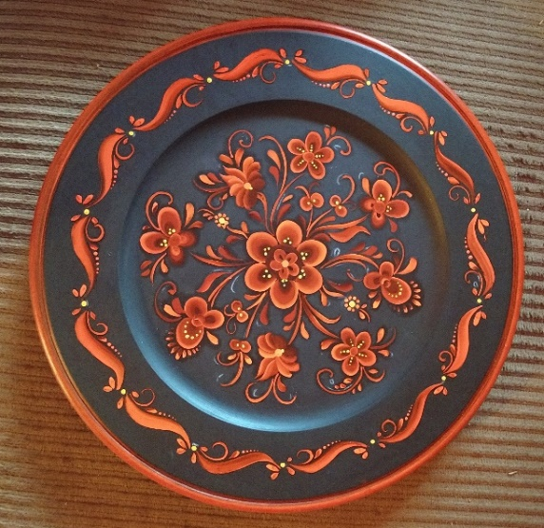
Raudsaumsmåling Class
With Kim Garrett
January 29 – 31, 2021
Looking for ideas of gifts to add to your own holiday wish list? Look no further - The INRA announces a post-holiday class to brighten the dreary days of winter.
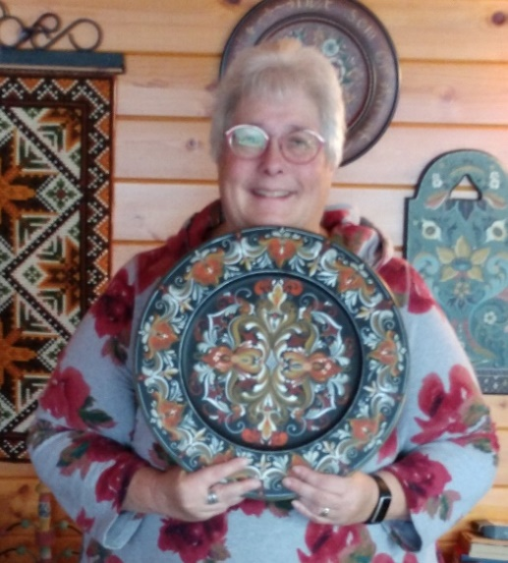
Kim Garrett will be snowbound up in Ely, Minnesota, come January, but she is looking forward to teaching this ten-hour rosemaling class via Zoom. Isn’t technology wonderful?

Whether you are a beginner at rosemaling, or a beginner at Raudsaumsmåling, this class is for you!

We will be working on a 12” plate with an 8” center using an original Raudsaumsmåling design created by Kim. The border of the plate can be completed using one of two options, one that will be similar to the one pictured above, and one more advanced border design for those who want to accept the challenge.
Kim Garrett holding a plate based on the style created by Gunnar Bø in More og Romsdal, Norway.

Class details:
The Dates: One weekend – January 29 -31, 2021, Four Zoom sessions -
Friday night (2 hr session, 7-9 pm), two on Saturday (two 2.5 hr sessions, 9-11:30 am and 12:30-3 pm) and Sunday afternoon (3 hr session, 1-4 pm)

The Style: Raudsaumsmåling – a Telemark style inspired by the red bunad designs of the Telemark region in Norway.

The Project – a 12” double-beaded plate with an 8” center and 2” border to be ordered by students from: www.Hofcraft.com : item WPDBR12 double beaded wide rim plate, or http://vikingwoodcrafts.com : item 18-1715 plate, convex, double bead 12 inch diameter. Please order your plate with plenty of time for it to be shipped directly to you. A supply list and project instructions will be sent to registered students soon after the registration deadline of January 5th. Note: All paints are to be purchased by students. Suggested paints, both oil and acrylic, will be noted in the supply list. Kim will be teaching the class in oils.

The Teacher - Kim Garrett – ‘Kim Garrett has been rosemaling since 2007 and has studied with several “Gold Medal” winning American rosemalers. She has traveled to Norway three times to study traditional 18th century rosemaling design with Norwegian rosemaling instructors. She has also taken lessons in Sweden in the Swedish folk art painting style, Dalmålning. She has won several blue ribbons at the MN state fair for her rosemaling and received the Best in Show twice.’ - Ely Folk School
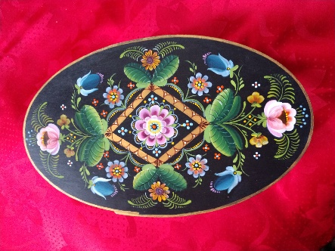
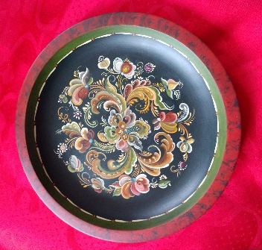
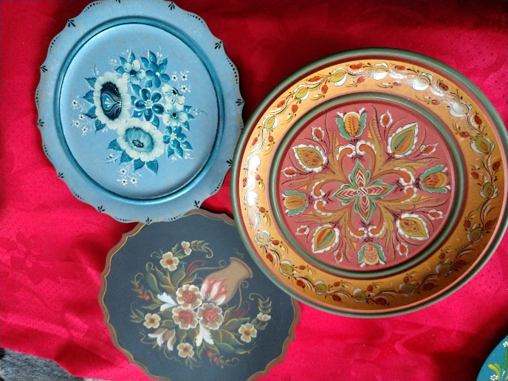
Samples of Kim Garrett’s work, from left to right – Setesdal, traditional Valdres, American Valdres, Telemark, and Os.

The Cost: $60.00 INRA Member, $75.00 Non-member (includes INRA membership fee of $15) includes 10 hours of class time, email/text help, and instructional materials - supply list, pattern, line drawings of details, color photo(s) and step by step instructions.
Questions? – Email Mari Smith at inrarosemaling@gmail.com. A Zoom practice session will be offered to registered students during the week prior to class.

REGISTRATION FORM FOR EDUCATION CLASSES AND EVENTS
Your Name: ________________________________________________________
Mailing Address: ____________________________________________________ ___________________________________________________________________
Phone: __________________ Email: ____________________________________
Please check appropriate line(s):
Raudsaumsmåling Beginner Class with Kim Garrett:
$75.00 Non-member (includes membership fee of $15) _____
$60.00 Member _____ (Check payable to INRA)
Class size: 6 students minimum/14 students maximum
Project piece to be ordered from supplier (see announcement text for details) and paint purchased by student as needed. Information given below is for teacher’s awareness and planning purposes:
Student’s Self-reported experience level:
True Beginner/new to rosemaling _____ Beginner _____ Intermediate _____
Student will be using oils _____ or acrylics _____in class. Note: Kim will be teaching the class in oils (as she has limited experience in acrylics).
Registrant confirms they have a computer/device with internet, microphone, and camera _____
Please send registration form and check (payable to: INRA) before January 5, 2021 to: Joanne Bjerga, 854 Knollwood Rd, Deerfield, IL 60015.

